Responsibility Modelling Tutorial

Responsibility modelling is a notation and methodology for modelling complex socio-technical systems - systems that combine human, organisational and technical elements. Responsibility models consist of actors, responsibilities and resources (collectively, we call these entities). We use responsibilities as the core element of these models because we believe that they are a more intuitive way of capturing real-world activities than goal or process models.
Responsibilities are tasks, duties and obligations and can range from very abstract moral or legal principles to specific details about a particular task or process. The aim of the system is to successfully complete (discharge) all the responsibilities, which may require the actions of actors or the use of resources. Both resources and actors are flexible - resources can be physical materials or pieces of information, and actors can be organisations, individuals or technical systems like computer programs or sensors.
A responsibility model consists of these three entity types, linked by relations. Relations are:
- Required actor/resource/responsibility: indicates that the required entity is necessary to discharge the source responsibility
- Production: indicates that a resource is produced by the successful discharge of a responsibility
- Holds: indicates that an actor is responsible for / accountable for a particular responsibility (This contrasts with required actor, which just indicates the actor is needed)
It is also important to note that responsibility models are stateless, unlike many similar notations. Responsibilities are either discharged or are not discharged, resources are produced or not produced etc. over the entire timeframe of the system, rather than in discrete steps. This simplifies the timing of a system - for example, we are not concerned how quickly a responsibility is discharged - it is simply either successful (and hence ready on time) or unsuccesful.
In our graphical representation, responsibilities are represented as rectangles, actors as stickmen and resources as ovals. Relations are indicated by directional arrows with filled arrowheads, with the exception of the Holds relation, which is a directional arrow with a open arrowhead. There is no specific notation for each type of relation - the type is inferred from the source and target entities.
Consider this example of ordering and eating food in a restaurant:

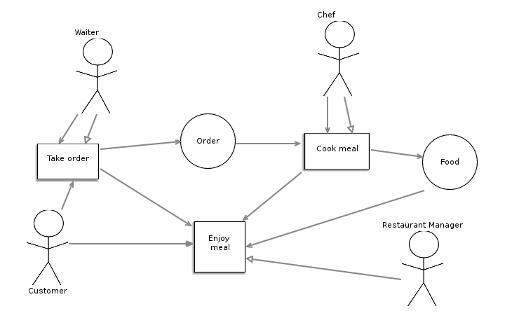

Here we have three responsibilities (Enjoy meal, Take order, Cook meal), four actors (Waiter, Customer, Chef, Restaurant Manager) and two resources (Order, Food). We can see that the customer and the waiter are both required in order to take the order, but only the waiter is accountable for it. The chef is both required for and is accountable for cooking the meal, which produces food as long as the order is available. The meal can be enjoyed as the order has been taken, the meal cooked, the food is available and the customer is available - the manager is not directly involved in any way, but is responsible for ensuring that it is successfully discharged.
There are lots of different techniques for creating responsibility models from source materials. We often use a system of entity detection similar that used for ER diagrams - read through source documents and identify the actors, responsibilities and resources and create them in the model, before making a second pass of the documents to determine the relations. Organisations and roles correspond to actors, while pieces of information correspond to resources and tasks, obligations etc. correspond to responsibilities. Of course, many other elicitation strategies are perfectly suitable.
We have developed a toolkit for responsibility modelling called RESME, which is available on GitHub: github.com/twsswt/resme
For each of installation, we recommend first making a clean install of the ObeoDesigner Eclipse build: obeodesigner.com/en which contains all the necessary dependencies. If you have any problems, do email us!

